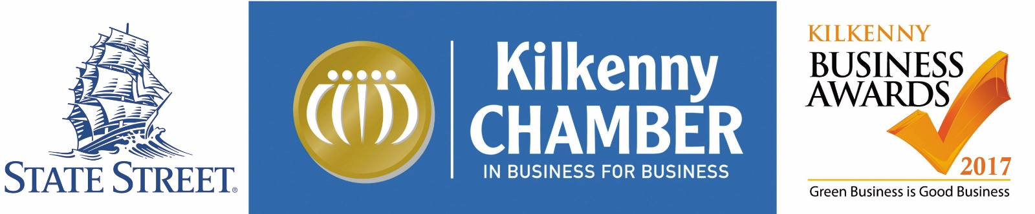

KILKENNY CHAMBER BUSINESS AWARDS 2017
OFFICIAL APPLICATION FORM

Congratulations! You have been nominated for the prestigious Kilkenny Chamber Business Awards. This is a wonderful opportunity to showcase your business and to receive due recognition of your achievements.

The Kilkenny Business Awards has become the most prestigious celebration of business success in Kilkenny and culminates in a glittering black tie awards ceremony at the 5 star Lyrath Estate Hotel on Saturday 25th November 2017.

All successful entrants will receive unrivalled media coverage and promotion of their business through newspaper, radio and online media.

Please complete and return this application form at your earliest convenience to be considered for one of the coveted Kilkenny Business Awards.

This application should be completed as thoroughly as possible. For further information please refer to the Kilkenny Business Awards 2017 Application Criteria, Conditions of Entry & Scoring available for download from the Chamber website www.kilkennychamber.ie .

Closing date for receipt of completed application forms is Wednesday, 6th October 2017.

Kilkenny Business Awards 2017,
Kilkenny Chamber Offices
The Malting’s, Tilbury Place,
James St,
KILKENNY
admin@kilkennychamber.ie

Kindly Sponsored By
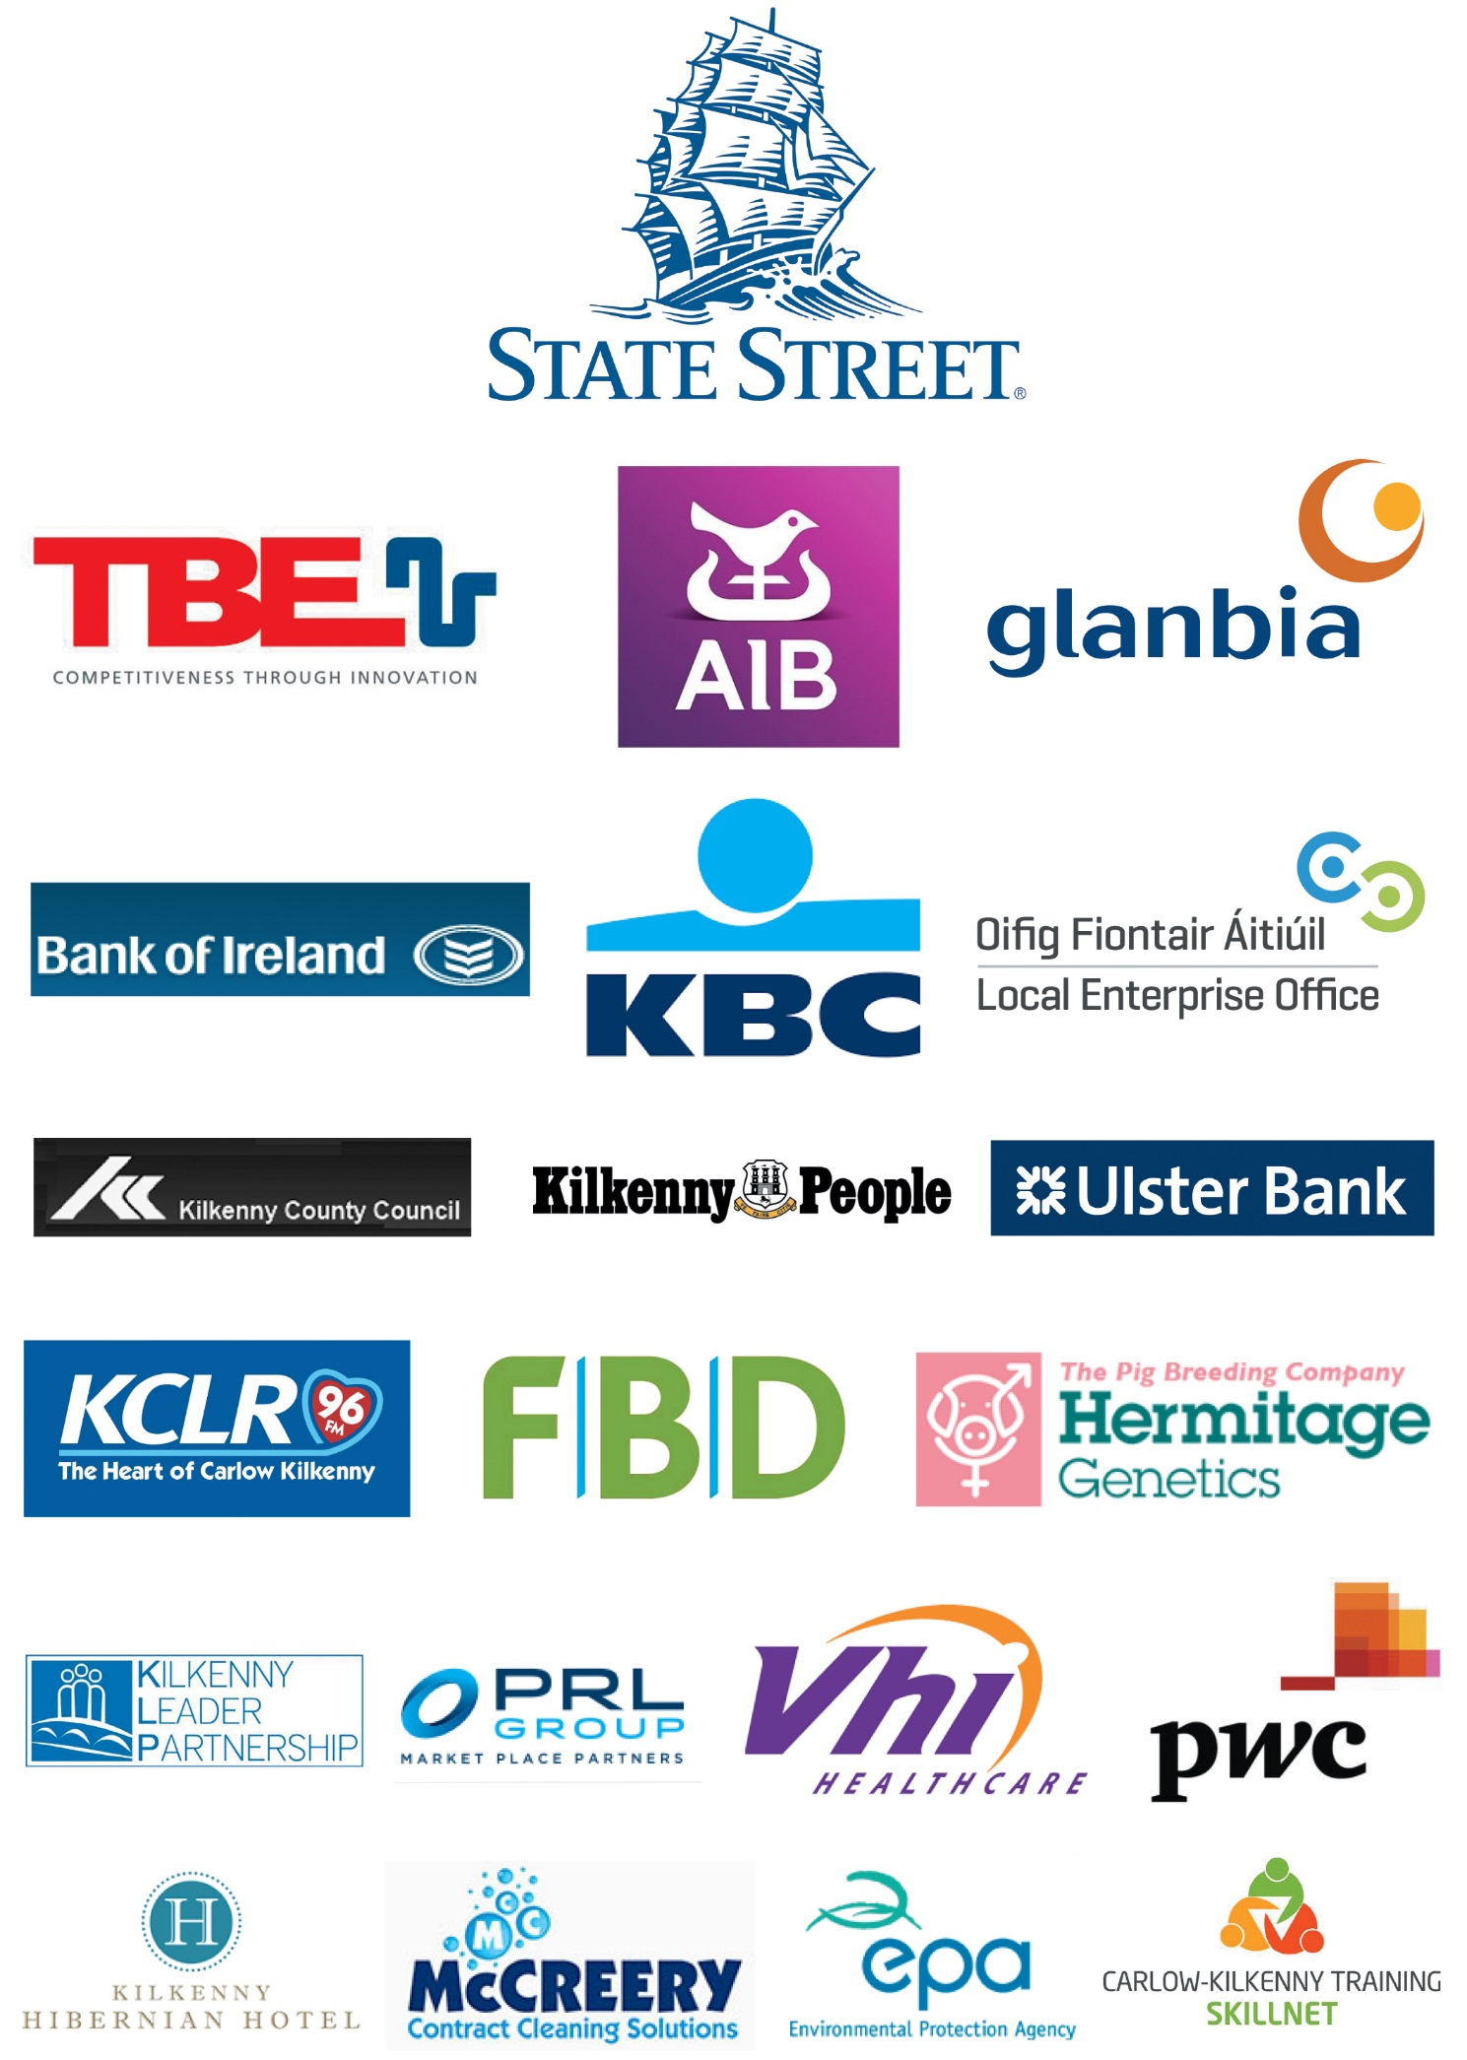

Last Year’s Winners
Agri Business of the Year | Hermitage Genetics
Craft Producer of the Year | Clay Creations
Culture / Heritage Tourism Award | Smithwick’s Experience Kilkenny
Customer Service Excellence | The Newpark Hotel
Emerging New Business | Core Claims Services
Employee of the Year | Margaret Clancy - TransferMate
Employer of the Year | Kieran O’Gorman Hair & Day Spa
Environmental Award | Modus Energy
Excellence in Communications | McSweeney Media
Excellence in Hospitality | Left Bank
Exporter of the Year | Hermitage Genetics
Family Business of the Year | M.Mullins Family Butcher
Food & Drink Producer of the Year | O’Shea Farms
Innovation in Business | Eco Life Energy
Best Venue of the Year | Lyrath Estate Hotel & Convention Centre
Information & Communications Technology | CipherTechs EU Ltd.
Investment in Skills, Training & Development of Staff | Rustiq Salon
Retailer of the Year | Grogan & Brown Artisan Butchers
Service Provider of the Year | Kieran O’ Gorman Hair & Day Spa
Small Business of the Year | RD Plumbing & Heating
Lifetime Achievement Award | Kathleen Moran
President’s Award | Paddy Kenna
Overall Business of the Year | Hermitage Genetics
What They Said
“Entering for the Kilkenny Business Awards was a tremendous experience for Hermitage Genetics in 2016. It forced us to stand back from our business and analyse what we do and how we do it and this proved to be a valuable learning experience for us.

Winning the Award for Overall Business of the Year was a fantastic endorsement for all of our staff who have worked so hard over the years and helped make the business what it is today. Kilkenny Chamber were thoroughly professional and very supportive to us throughout the whole process and I would strongly encourage all Kilkenny businesses to get involved”.
Ned Nolan, Hermitage Genetics
---------------------------------------------------------------------
“Winning the ‘Excellence in Communications’ category at the 2016 awards catapulted McSweeney Media into the limelight and I’m delighted to report that company revenue has grown significantly since. We immediately added news of our award win in the form of a banner at the bottom of our emails. We shared news of our success on various social media platforms and mailshotted all of our clients to share our good fortune. Featuring the joint Glanbia and Chamber logos on all electronic correspondence has helped us to stand out, to grow our international profile, win higher value projects and ultimately increase revenues by as much as 30 per cent so far this year.

The Awards process encouraged us to really focus on our strengths, address any weaknesses, to plan for the future and ensure that we meet the targets and the goals we set ourselves in our presentation to the expert judging panel. We plan to compete again this year and would strongly encourage other firms to follow suit”.
Neans McSweeney, Owner/Director of McSweeney Media Ltd

APPLICATION FORM
NOTE:
Please refer to LINK for a description of each category (see full Category Descriptions). Businesses entering the awards are asked to thoroughly complete sections 1 – 6 where applicable. Within section 5, some questions may not apply to your industry sector and can be left blank.

Those individuals entering under the Employee of the Year categories please complete sections 1, 2 and 6 below.

- AWARD CATEGORIES

Please select up to three categories that you wish to enter.

☐ AGRI BUSINESS OF THE YEAR
☐ FOOD & DRINK PRODUCER OF THE YEAR
☐ EXPORTER OF THE YEAR
☐ EXCELLENCE IN COMMUNICATIONS
☐ INNOVATION IN BUSINESS
☐ EXCELLENCE IN HOSPITALITY
☐ CUSTOMER SERVICE EXCELLENCE
☐ SERVICE PROVIDER OF THE YEAR
☐ RETAILER OF THE YEAR
☐ INFORMATION & COMMUNICATIONS TECHNOLOGY (ICT)
☐ EMPLOYER OF THE YEAR
☐ EMPLOYEE OF THE YEAR
☐ CULTURE/HERITAGE TOURISM AWARD
☐ CRAFT PRODUCER OF THE YEAR
☐ FAMILY BUSINESS OF THE YEAR
☐ EMERGING NEW BUSINESS
☐ SMALL BUSINESS OF THE YEAR
☐ INVESTMENT IN SKILLS, TRAINING & DEVELOPMENT OF STAFF
☐ ENVIRONMENTAL AWARD
☐ CORPORATE SOCIAL RESPONSIBILITY

Kilkenny Chamber of Commerce undertakes to treat as strictly confidential all information provided to it in this Application Form. Furthermore Kilkenny Chamber of Commerce shall not at any time use any information provided for any other purpose other than in connection with the evaluation of the company and/or individual providing that information for an award for which it has been nominated.

- BUSINESS DETAILS

Business Owner(s) Name(s):

Business Name (Trading Name):

Describe the Business products/services offered in 50 words. (Please include/attach any details of your business vision, mission or core values and organisational structure if available)

Applicant’s Name: (Completing the application on behalf of the individual or business).

Business Address:
E-mail:
Twitter handle @
E-mail:
Tel:
Business Registered Name & Number:

BUSINESS STRUCTURE
Mob:
Business Website:

Sole Trader: ☐ Partnership: ☐ Limited Company: ☐ Franchise: ☐

Co-operative: ☐ Local Government: ☐ Multi-National: ☐

Not for profit: ☐ Registered Charity: ☐
Other (please describe)

Year business was established
No of staff employed in year 1

Nos. of contracted staff engaged
Total No. of direct employees currently employed eeeeeemememployedemployed
No of Whole Time Equivalent Staff (WTE)
Full time Part time Seasonal

- FINANCIAL DETAILS
Please detail your annual turnover (All data supplied will remain confidential).

2017 (Projected)

Up to €300K ☐ €300K - > €1M ☐ €1M- €3M ☐ > €3M ☐

Please indicate the percentage by which your turnover increased or decreased since 2014.

+ % or - %

- If applicable to your business, please confirm what % of your business turnover (if any) comes from exporting out of Ireland.
%

Please describe any initiatives/measures being taken to develop export markets for your business (if relevant) and list those countries that you currently export to.

- BUSINESS ADMINISTRATION AND MANAGEMENT
Describe how your business supports the local economy (i.e. Use of local suppliers/resources, providing employment and engaging in social development initiatives for the area)

Describe the key strengths, USP’s (unique selling points) and competitive advantage of the business

Describe any environmental and/or green policies and practices applied within the business and detail any awards achieved in this area

Describe the communications polices, processes and technologies used in the business – with customers, staff, public, media:

Describe the customer service policy and practices of the business:

How do you ensure quality is consistently delivered throughout all aspects of your business?

Describe the development of your business and the challenges encountered in the past 2/3 Years?

Describe the measures taken within the business for development and growth.

How have staffing levels/arrangements had to change/flex in the last 2-3 years to meet business demands?

Describe how your business assesses and manages business risks

- BUSINESS ADMINISTRATION SPECIFIC INDUSTRY SECTORS

Where applicable how has your business applied innovation in its development/operation over the past 2-3 years?

Where applicable how does your business manage and evaluate staff performance/skills training and new business expertise.

Outline your businesses Corporate Social Responsibility policy and describe a project or initiative in this context that has been undertaken including details of what its aims were, how it was rolled out and what outcomes resulted including how those outcomes were measured.

Where applicable detail how new technologies, online marketing, sales and information platforms & Management Information Systems (MIS) including financial reporting systems are used to continuously improve business performance and drive growth and consistency of service

Describe how your business has embraced Information & Communications Technology (ICT) and how the ICT strategy has benefited your business.

6. ADDITIONAL APPLICATION DETAILS
Please outline details about what sets your business/individual apart from others and why you think the business/individual should be selected as the winner in the chosen category/categories Note: (please use bullet points below; you will have greater opportunities to elaborate on these reasons in a shortlist interview presentation, if you are shortlisted for the award.)

Please outline what a Kilkenny Chamber Business Award would mean to your business and team
In your response to this question, please include details of how you would use the momentum of the accolade to further develop your business, whether that be in terms of marketing, promotion, quality assurance, customer service, staff development, innovation, greening your business or any other area of business development:

Any additional information. Please use this space to detail any information you feel is important /would support your application that is not already captured in the Application Form questions above. If relevant, you should list here any additional documentation you are submitting to support your application:

I confirm this application is completed honestly and accurately

Signature of Applicant

Role in Business Date

Check list for Applicants

☐ Selected up to three categories for nomination
☐ Thoroughly completed application form
☐ Additional support information, brochures etc.
☐ Corporate Logo
☐ 3 high resolution business images
☐ 50 word company or individual biography
☐ Save the date – Panel Interview Wednesday 25th October 2017 &
Award Ceremony Saturday November 25th 2017.

IMPORTANT: Please provide a copy of your corporate logo, a 50 word company or individual biography (if not already included under Section 2 Business Details) and 3 images via email to accompany your application to admin@kilkennychamber.ie. We suggest an individual profile image, business product or service image and business exterior image if possible. Please provide the logo and images in a high resolution format as they will be used on large screens for the presentation at the award ceremony on November 25th 2017.

For those submitting applications via post or hand delivery, please email images and bios to admin@kilkennychamber.ie or include a disc or USB with this information.

