Winners 2018 |  | Sponsors
- Agri Business of the Year | 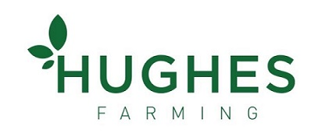 | FBD Insurance
- Social Enterprise of the year | 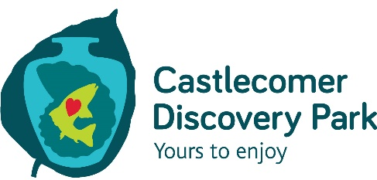 | Kilkenny Leader Partnership
- Craft Producer of the Year | 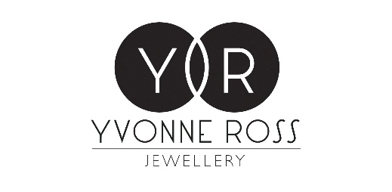 | Kilkenny Co Council
- Culture / Heritage Tourism Award | 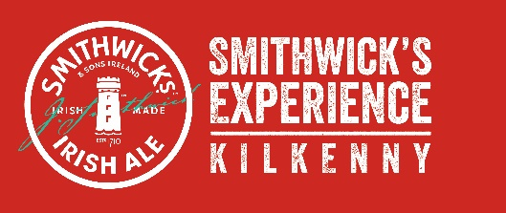 | Kilkenny People
- Customer Service Excellence |  | Ulster Bank
- Emerging New Business | 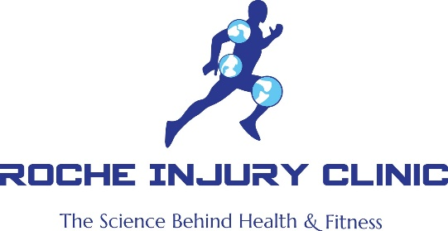 | Taxback Group
- Employee of the Year |  | KBC Bank
- Employer of the Year |  | T Butler Engineering
- Environmental Award | 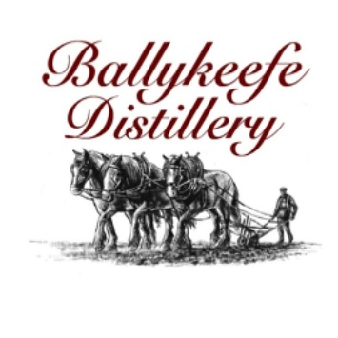 | Environment Protection Agency
- Excellence in Hospitality | 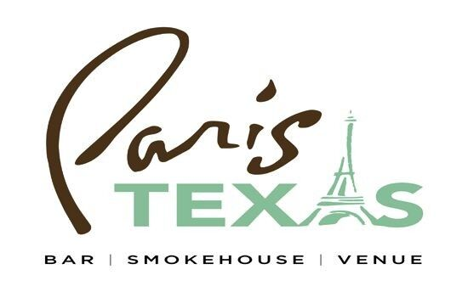 | PRL Group
- Exporter of the Year | 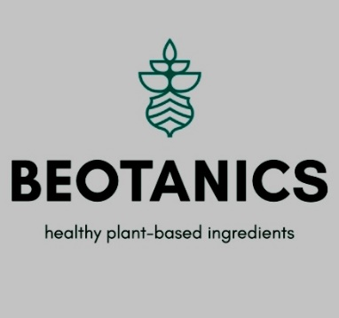 | Bank of Ireland
- Family Business of the Year | 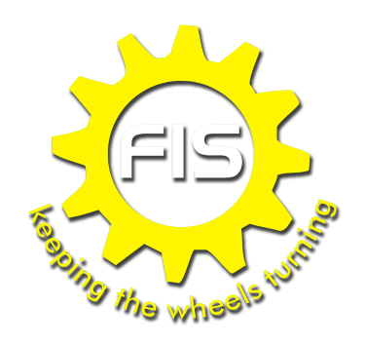 | Price Waterhouse Cooper
- Food & Drink Producer of the Year | 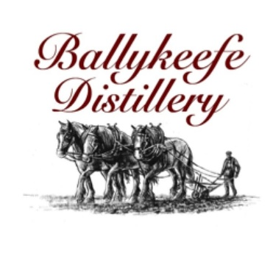 | The Wine Centre
- Information & Communications Technology | 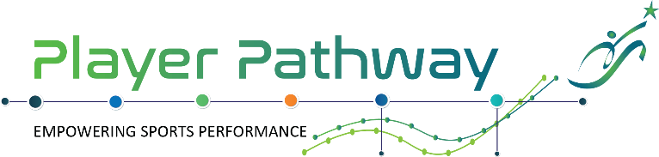 | Hermitage Genetics
- Innovation in Business | 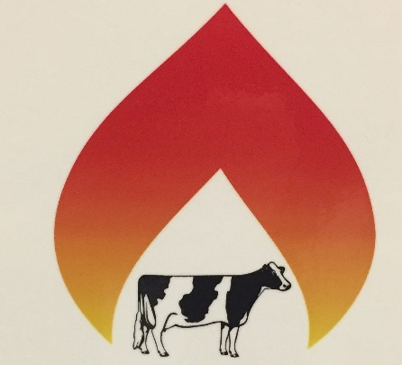  DAIRY GEYSER | Glanbia
- Investment in Skills, Training & Development of Staff |  | Skillnet
- Retailer of the Year |  | AIB Bank
- Service Provider of the Year |  | VHI Healthcare
- Small Business of the Year | 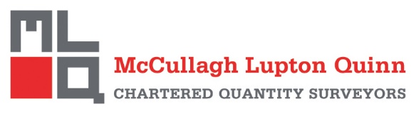 | Local Enterprise Office
- President’s Award | Nora Twomey | Kilkenny Chamber
- Lifetime Achievement Award | Rudolf Heltzel | Kilkenny Chamber
- Overall Business of the Year |  | Kilkenny Chamber

